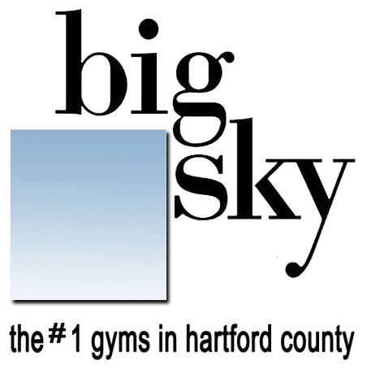
simsbury group fitness classes
effective 3/13/2024

club hours
mon-thu 5:00a - 10p
friday 5:00a - 8p
saturday 7:00a - 5p
sunday 7:00a - 2p

mon | tue | wed | thu | fri | sat | sun
5:30a spinning  (60 minutes -bryan)  7:45a cardio-core  (60 minutes- susan)  9:00a bodypump  (60 minutes- brigid)  10:15a pilates matwork  (60 minutes- tracey)  PM  5:00p all levels yoga  (60 minutes- barbie/chris/melissa/susan)  6:00p spinning  (60 minutes- chris m) | 8:00a pilates/barre fusion  (60 minutes- susan)  9:15a spinning  (60 minutes- tracey)  PM  5:15p bodypump  (60 minutes- chris f) | 5:30a spinning  (60 minutes- bryan)  7:00a biker barre  (60 minutes- susan)  9:00a cardio-kick  (60 minutes- brigid)  10:15a pilates matwork  (60 minutes- tracey)  PM  5:00p yoga foundations  (60 minutes- chris f)  6:00p spinning  (60 min.- chris m)  6:15p cardio-kick  (60 minutes– brigid) | 8:00a all levels yoga  (60 minutes- susan)  9:15a spinning  (60 minutes- marianne)  PM  4:45p hard-core  (30 minutes– brigid/susan)  5:30p bodypump  (60 minutes- brigid/susan) | 5:30a spinning  (60 minutes- suzi)  7:30a pilates matwork  (60 minutes- marianne)  9:00a bodypump  (60 minutes- brigid) | 8:00a cardio-interval  (45 minutes- kerri)  9:00a bodypump  (60 minutes-kerri)  10:15a power-flow yoga  (75 minutes- jim) | 9:00a bodypump  (60 minutes- chris f)  9:15a spinning  (60 minutes - marianne)  10:15a all levels yoga  (60 minutes- barbie/jim/melissa/susan

class descriptions *
bike training
biker barre: A unique combination of Spinning and Barre set to high energy motivating music.

spinning: This class matches terrain to tempo with all the energy of a rock concert. You’ll encounter slow climbs, short sprints and everything in-between.

mind, body & core **Please bring your own mat and props to class**
Pilates/barre fusion: This class involves the principles and movements of a traditional Pilates class while incorporating a blend of ballet-inspired elements.
Barre Fusion often focuses on small, isometric movements delivering a full-body workout. Especially great for strengthening your core and toning your
glutes and legs.

pilates matwork: Accomplish physical and mental conditioning through floor exercises performed with specific breathing patterns.
Pilates will strengthen your major muscle groups, improve your alignment, and increase your flexibility.

power flow yoga: A faster moving yoga class designed to challenge those with some yoga experience. More advanced poses are
demonstrated and less verbal instruction may be given, as poses may be linked together in a “flow”. Come hydrated and prepared to sweat!

all levels yoga: A mind and body training program that will change the way you feel about your body forever. You’ll stand straighter,
feel stronger and become more flexible. Designed for all fitness levels, this class will reduce your stress and relieve your pain.

yoga foundations: A great place to begin your yoga practice or to keep refining your form and technique.

cardio
cardio-kick: A cardio based interval training workout where you are totally unleashed! This fiercely energetic program is inspired by martial arts and draws from a
wide array of disciplines. Strike punch and kick your way through calories to superior cardio fitness.

cardio-core: A combination of aerobics and step guaranteed to have you breaking a sweat! Finished off with a series of floor exercises to help you strengthen your
back, abs and hips.

cardio-interval: each week the intervals and equipment used could change to make for increased calorie burn and a total body workout. Some weeks could be
kickbox intervals, other weeks it might be a boot-camp style workout, step or cardio drills. One thing is for sure… every week you’ll sweat!

zumba®: Zumba fuses hypnotic latin rhythms and easy to follow moves. The routines feature interval training sessions where fast and slow rhythms, and
resistance training are combined to tone and sculpt your body while burning fat. Get ready to DANCE!!

strength training
bodypump: Bodypump is the revolutionary new weight-training workout in a group fitness setting. You’ll use barbells with adjustable weights,
set to motivating music, and you’ll burn up to 600 calories in an hour. WARNING: Bodypump is an exercise routine that gets results…fast!

buff 101: Resistance training class designed to tone, condition, and define major muscle groups using hand-weights, body-bars, and/or exer-tubes. Followed
by a total body stretch.

hard core: Torch your core (from shoulders to hips and everything in between). This 30-minute class helps you build functional strength and
prevent injury. Options are shown for all fitness levels. Stronger Core. Stronger Everything!

